Boosting Sales at A.R Furniture through Strategic Inventory Optimization and Customer Centric Design

A Mid-Term report for the BDM capstone Project

Submitted by:

Name: Abdul Hadi
Student Email: 22f1001445@ds.study.iitm.ac.in
Roll No: 22f1001445


IITM Online BS Degree Program,
Indian Institute of Technology, Madras, Chennai
Tamil Nadu, India, 600036

Contents

- Executive Summary 3.
- Proof Of Originality 3.
2.1 – Letter from the Organisation
2.2 – Video of Interaction with the Owner
2.3 – Images of The Firm
2.4 – DATA
- Metadata and Data Description 3-6
3.1 Data Sources and Collection
3.1.1 Data Collection Method
3.2 Variable Description and Dataset Summary
- Descriptive Statistics 6-8
4.1 Overall Business Performance Summary
4.2 Product-wise Statistical Analysis
4.3 Monthly Performance Trends
4.4 Statistical Interpretation
4.5 Summary Statement
- Analytical Approach and Justification 8-9
5.1 Data Collection and Pre-Processing
5.1.1 Raw Material Sales Data
5.1.2 Retail Sales Data
5.1.3 Purchase Data
5.2 Descriptive Statistical Analysis
5.3 ABC Classification
6. Result and Findings 9-12
6.1 Product-Wise Revenue and Profit Contribution (Raw Sales)
6.2 ABC Classification Findings
6.3 Monthly Profit Trend Analysis (Grouped by Month)
6.4 Retail Sales Findings (Prepared Product Sales)
1. Executive Summary:
A.R Furniture is a small, unorganized furniture business in Ranchi, Jharkhand (834001), owned by Mr. Zahid Akhtar. The shop serves both B2B carpenters and B2C retail buyers, selling raw frames and limited ready-made items. Despite steady demand, the business faces issues such as unstructured inventory, inconsistent pricing, and a lack of data-driven decisions. This project aims to analyse four months of actual sales and purchase data to identify patterns that can improve stock planning, pricing, and overall product strategy.
For the mid-term, I collected primary data from the owner, including 4 months of raw sales, purchase bills, and reconstructed retail sales records. All datasets were cleaned and analysed in Excel using summary tables, pivot charts, and metadata tables describing variable types and dataset structure.
The analytical methods included descriptive statistics to study variation in cost and sales values, ABC classification to identify profit-dominant raw items, and retail profitability analysis comparing preparation cost with selling price. These methods directly address key business challenges such as inventory imbalance, unpredictable margins, and unclear fast-moving items.
Initial results show that sofa and bed frames (SSF-D, SSF-A, SSF-B, BSF-C) generate most profits, while several items have low contribution. Total sales amounted to ₹3,69,152 with ₹54,979.5 profit. Profit varied by month, with June highest (₹20,305.5) followed by July (₹14,787). ABC classification showed 7 A-category items contributing nearly 75% of total profit, led by Teak Sawn Timber (₹7,846.5) and SSF-D (₹8,960). Retail sales had higher margins (15–25%), while raw sales had higher volume but lower margins.
The final phase will convert these insights into practical recommendations for stock control, pricing, and customer-focused improvements.
2. Proof of Originality:
2.1 – Letter from the Organisation
2.2 – Video of Interaction with the Owner
2.3 – Images of The Firm
2.4 – DATA
3. Metadata and Data Description
3.1 Data Sources and Collection
This analysis is based on primary operational data obtained directly from A.R. Furniture's owner, Mr. Zahid Akhtar. The data represents real transactions from April to July 2025.
3.1.1 Data Collection Method:
- Purchase Data: Manually extracted from supplier invoices (primarily Raja Leo Furniture, Hazaribagh).
- Sales Data: Collected from handwritten bills and ledger entries maintained at the store. The records were taken from manual bills and later organized in Excel for analysis.
- Retail Data: Constructed using cost components (raw materials, polishing, carpenter wages, miscellaneous costs) derived from verbal and ledger-based estimates provided by the owner. These values represent realistic business-level approximations rather than automated system data.
Time Period: April 1, 2025 - July 31, 2025 (4 months)

3.2 Variable Description and Dataset Summary
Table 3.2.1: Dataset Overview
Dataset | Rows | Columns | Description
Purchase | 38 | 6 | Records of raw material and furniture frame purchases from suppliers
Raw Sale | 70 | 10 | Transactions of furniture parts and timber sold to customers
Retail Sale | 13 | 20 | Sales of finished, assembled furniture products to end consumers
Raw Summary | - | - | Aggregated calculations and analysis of raw material transactions
Retail Summary | - | - | Aggregated calculations and analysis of retail transactions

Table 3.2.2: Column-wise Data Description
Dataset | Column Name |  | Data Type | Description | Example Values
Purchase | Date |  | Date | Purchase transaction date | 2025-04-04
 | Item Code |  | Text | Unique product identifier | BSF (A), SSF(B)
 | Item Description |  | Text | Full product name | Bed Side Frame (A)
 | Qty |  | Numeric | Quantity purchased | 2, 12, 25.1
 | Rate |  | Numeric | Unit price (₹) | 2480, 2731
 | Total Amount |  | Numeric | Qty × Rate (₹) | 4960, 7812
Raw Sale | Date |  | Date | Sales transaction date | 2025-04-02
 | Item Code |  | Text | Unique product identifier | CTSF (A), DCF (B)
 | Item Description |  | Text | Full product name | Centre Table Side Frame (A)
 | Qty |  | Numeric | Quantity sold | 6, 4, 1
 | Rate |  | Numeric | Selling price per unit (₹) | 985, 660
 | Total Amount |  | Numeric | Qty × Rate (₹) | 5910, 2640
 | Customer Type |  | Text | Customer category | Carpenter, Retail, Not Available
Retail Sale | Retail Date |  | Date | Finished product sale date | 2025-04-05
 | Product Name |  | Text | Finished product name | Bed (A), Sofa (B)
 | Components Used |  | Text | Raw materials used | BSF (A), SSF (B) + CTF (A)
 | Raw Material Cost |  | Numeric | Cost of components (₹) | 2923, 3975
 | Total Preparation Cost |  | Numeric | Sum of all costs (₹) | 14073, 20032
 | Selling Price |  | Numeric | Final sale price (₹) | 17100, 23500
 | Profit |  | Numeric | Selling Price - Total Cost (₹) | 3027, 3468
 | Profit Margin |  | Percentage | (Profit/Total Cost) ×100 | 21.5%, 17.3%
 | Customer Type |  | Text | Always "Retail" | Retail
 | Ply Cost |  | Numeric | Plywood cost: Layered engineered wood sheet used in beds, cabinets, and structural components. Provides strong support while remaining lightweight and affordable. | 3250, 3750
 | Glass Top Cost |  | Numeric | Glass top cost: Smooth, flat tempered glass placed over dining/centre tables. Serves as protective surface and decorative enhancement. | 2657, 2825
 | Veneer Cost |  | Numeric | Veneer cost: Thin decorative layer of fine-quality wood applied over plywood base. Provides premium appearance with cost efficiency. | 700
 | Cushion Cost |  | Numeric | Cushion cost: Used primarily in sofas and seating furniture, created using customer-preferred fabric designs and colours.3200, 3500 | 3200, 3500
 | Polisher Cost |  | Numeric | Polishing and finishing cost (₹) | 3500, 4500
 | Carpenter Cost |  | Numeric | Carpenter wages for assembly (₹) | 2700, 3200
 | Misc Cost |  | Numeric | Miscellaneous expenses (₹) | 1000, 2500
 | Selling Price |  | Numeric | Final sale price to customer (₹) | 17100, 23500
 | Profit |  | Numeric | Selling Price - Total Cost (₹) | 3027, 3468

- Descriptive Statistics:
This section presents the statistical summary of A.R. Furniture's transactional data from April to July 2025. All calculations are based on the consolidated data from the Purchase, Raw Sale, and Retail Sale sheets.
4.1 Overall Business Performance Summary
Table 4.1.1: Key Business Metrics Summary
Metric | Value | Calculation Basis
Analysis Period | 4 months (Apr-Jul 2025) | -
Total Purchase Amount | ₹3,28,929.5 | Sum of Total Amount in Purchase  sheet
Total Raw Sales Amount | ₹3,69,152 | Sum of Total Amount in Raw Sale sheet
Total Retail Sales Amount | ₹2,13,100 | Sum of Selling Price in Retail Sale sheet
Combined Total Sales | ₹5,91,252 | ₹369,152 + ₹2,13,100
Total Business Profit | ₹86073.5 | ₹54979.5 (Raw) + ₹31094 (Retail)
Number of Purchase Transactions | 37 | Count of rows in Purchase sheet
Number of Raw Sales Transactions | 69 | Count of rows in Raw Sale sheet
Number of Retail Sales Transactions | 12 | Count of rows in Retail Sale sheet

4.2 Product-wise Statistical Analysis
Table 4.2.1: Purchase Descriptive Statistics (Purchase Sheet)
Statistic | Quantity Purchased (Qty) | Purchase Rate (₹) | Total Purchase Amount (₹)
Mean | 5.72 | 1869 | 8889.99
Median | 5 | 1275 | 6150
Mode | 2 | 2731 | 4960
Standard Deviation | 4.55 | 1274.04 | 6627.52
Skewness | 2.52 | 0.61 | 1.03
Range | 23.10 | 3790 | 24,575
Minimum | 2 | 540 | 1780
Maximum | 25.10 | 4330 | 26,355

Table 4.2.2: Raw Sales Descriptive Statistics (Sales Sheet)
Statistic | Quantity Sold (Qty) | Sales Rate (₹) | Total Sales Amount (₹)
Mean | 3.35 | 2113.97 | 5350.03
Median | 3 | 1200 | 3400
Mode | 1 | 623 | 2492
Standard Deviation | 2.70 | 1529.90 | 4181.95
Skewness | 1.79 | 0.74 | 1.37
Range | 11.55 | 4827 | 17,250
Minimum | 1 | 623 | 750
Maximum | 12.55 | 5450 | 18,000

4.3 Monthly Performance Trends
Table 4.3.1: Monthly Sales and Profit Analysis
Month | Raw Sales (₹) | Retail Sales (₹) | Total Sales (₹) | Raw Profit (₹) | Retail Profit (₹) | Total Profit (₹)
April | 55581 | 40600 | 96181 | 8625 | 5511 | 14136
May | 86578 | 35400 | 121978 | 11262 | 5465 | 16727
June | 138214 | 50100 | 188314 | 20305.5 | 6314 | 26619.5
July | 88779 | 86000 | 174779 | 14787 | 13804 | 28591
TOTAL | 369,152 | 212100 | 581252 | 54,979.5 | 31094 | 86,073.50

4.4 Statistical Interpretation
Key Insights from Descriptive Statistics:
4.4.1: Highly Variable Purchase & Sales Quantities
- Purchase Qty: Mean = 5.72, Std. Dev = 4.55
- Sales Qty: Mean = 3.35, Std. Dev = 2.70
- Both datasets show right-skewness (Purchase skew = 2.51, Sales skew = 1.79)
Insight: Purchases are made in irregular bulk quantities (up to 25 units), while sales are much more stable. This indicates overstocking risk and inefficient purchase planning.
4.4.2: Right-Skewed Price Distribution (High-Value Products Dominating)
Purchase Dataset:
- Mean Rate = ₹1,869 > Median Rate = ₹1,275
- Std. Dev = ₹1,274, which is 68% of mean
- Skewness = 0.61 (positive skew)
Sales Dataset:
- Mean Rate = ₹2,113 > Median Rate = ₹1,200
- Std. Dev = ₹1,529, which is 72% of mean
- Skewness = 0.74 (positive skew)
Insight: A few high-priced items (e.g., ₹5450 sofa frames, ₹4540 bed frames) pull the average upwards. This confirms that high-value SKUs disproportionately influence revenue, validating ABC classification.
3. Profitability Behaviour (Indirect from Price Variation)
Although raw sales profit is not directly shown here, the price statistics demonstrate:
- High dispersion in prices → high variation in profit per item
- Positive skewness → large profits from few high-value frames
- Small ticket items → stable but low-margin revenue
Insight:
Retail (finished products) naturally offers stable margins, while raw sales are high volume but unpredictable.
4.5 Summary Statement:
The descriptive statistics clearly reveal that A.R. Furniture suffers from high revenue variability, irregular purchasing behaviour, and strong dependence on a few high-value SKUs. These insights quantitatively validate the business challenges identified earlier specifically inventory imbalance, inconsistent demand, and the need for structured product classification (ABC), pricing controls, and procurement optimization.
- Analytical Approach and Justification:
The analysis for A.R. Furniture was conducted primarily using Microsoft Excel, chosen for its accessibility and versatility in handling structured and unstructured datasets. Two datasets were used the Raw Sales Data (furniture parts sold to carpenters and retail) and the Retail Sales Data (finished furniture sold to customers). The objective was to identify high-value products, analyze sales profitability, and derive insights for inventory optimization.
5.1 Data Collection and Pre-Processing
The dataset used consists of:
5.1.1 Raw Material Sales Data
Includes item code, item description, quantity sold, rate, and total amount.
- Cleaning involved correcting inconsistent item codes, converting numerical text fields to number format, and removing duplicates.
- Missing values were inspected and none required imputation.
- Date entries were standardized to DD-MM-YYYY format for time-series grouping.
5.1.2 Retail Sales Data (12 transactions)
Includes item name, raw material cost, labour cost, polishing cost, selling price, and profit.
- Processing steps involved calculating total preparation cost, profit, and profit margin for each item.
- Product combinations (e.g., Sofa + Centre Table) were treated as single composite entries.
5.1.3 Purchase Data (37 transactions)
Used to compute input cost behaviour and compare with sales volume for inventory planning.
Why this step is necessary:
Pre-processing ensures consistency and accuracy of downstream analytics. Improperly cleaned data can distort profit, ABC classification, or monthly growth patterns, leading to wrong managerial decisions.
5.2 Descriptive Statistical Analysis:
Descriptive statistics were performed on key variables such as Quantity Sold, Total Amount, and Profit (raw and retail).
Metrics computed: mean, median, mode, standard deviation, kurtosis, skewness, minimum, maximum, range, and total.
Justification:
Descriptive statistics help understand:
- the central tendency of sales (average performance)
- variability (uncertainty in demand)
- skewness (presence of extreme sales items),
- product stability vs. volatility, which is essential for stocking decisions.
For example:
- Raw sales show high skewness (1.37) and high variability, indicating that a few high-value items drive revenue
- Retail sales show consistent margins (15–25%), indicating price stability.
This insight is crucial for inventory optimization and pricing strategy.
5.3 ABC Classification
ABC analysis was applied on profit contribution for raw sales products.
Method Used:
- Calculate total profit for each item.
- Compute Profit Contribution of each item to total profit.
- Sort in descending order.
- Compute cumulative percentage.
- Classify:
- A-Category: Top ~70% contribution
- B-Category: Next ~20% contribution
- C-Category: Bottom ~10% contribution
Justification:
This method identifies:
- high-value items needing tight inventory control (A-Category),
- medium-value items requiring moderate control (B-Category),
- low-value items where stocking can be minimized to reduce working capital (C-Category).
This is the most appropriate technique because A.R Furniture faces inventory mismanagement and stockouts, which ABC directly addresses.
6. Results and Findings
The analytical results derived from four months of data (April–July 2025) provide a clear understanding of A.R. Furniture’s operational and sales performance. Using Excel-based analysis, both raw furniture (frames and materials) and retail ready-made furniture were examined for profitability, sales distribution, and inventory priority. The findings reveal key trends that can directly support data-driven decision-making.
6.1 Product-Wise Revenue and Profit Contribution (Raw Sales)
An item-wise pivot analysis of raw material sales entries shows substantial variation in revenue contribution across products.
Key Findings
- Teak Sawn Timber contributes the highest total revenue: ₹62,772 and a profit of ₹7,846.5.
- Sofa Side Frames (A–D) collectively contribute ₹161,850 and a profit of ₹27276, making them the top raw material category.
- Dining Chair Frames (DCF) show high volume (28 units for DCF-D) but relatively lower margin per unit.
- Items like BSF (B) and Chair Frame (B) contribute minimally, falling into the C-category of ABC classification.
Figure 6.1: Product-Wise Total Sales Amount (Raw Material Sales)
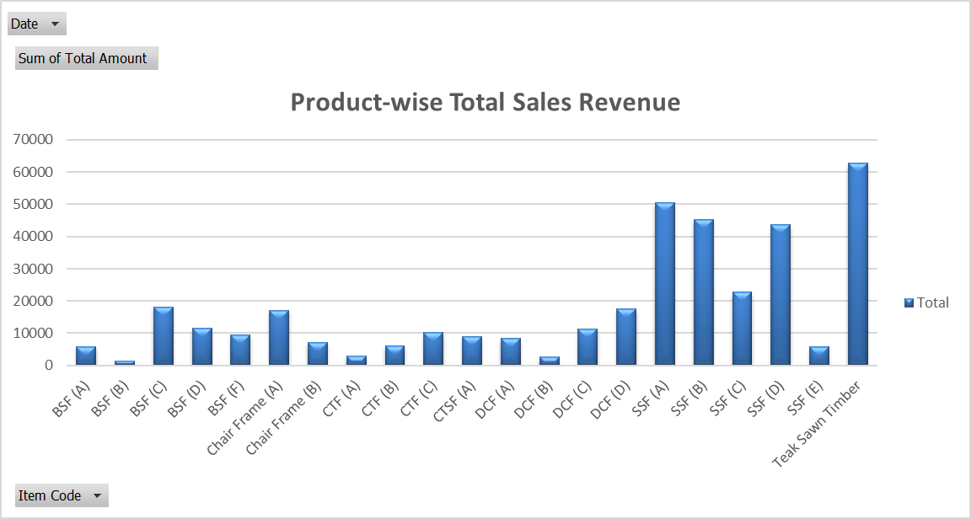
Interpretation
The chart shows a classic right-skewed distribution, where a few items generate disproportionately high revenue. This confirms the need for selective stocking, better procurement planning, and inventory prioritization for A-category items such as SSF (A–D) and Teak Timber.
6.2 ABC Classification Findings
ABC classification was performed using profit contribution percentage.
Results Overview
- Category A (Top 70%)
Includes SSF (A–D), BSF (C), DCF (D), and Teak Sawn Timber.
These items generate ~70% of total profit.
- Category B (Next 20%)
Includes medium performers such as CTF (C), BSF (F), DCF (A–C).
Moderate demand but essential for regular carpentry orders.
- Category C (Bottom 10%)
Includes BSF (B), Chair Frame (B), CTF (A).
Low sales + low margins → should be stocked minimally.
Interpretation: ABC analysis indicates that inventory mismanagement is mainly due to overstocking of low-value C-category items and irregular purchasing of high-performing A-category items.
Focusing purchasing on A-items will improve cash flow and reduce stockouts.
Figure 6.2: ABC Classification – Cumulative Profit Contribution (%)

6.3 Monthly Profit Trend Analysis (Grouped by Month)
Using the grouped date pivot table:
Month | Total Profit (₹)
Apr 2025 | 14136
May 2025 | 16727
Jun 2025 | 26619.5
Jul 2025 | 28591

Interpretation
- June shows the highest profit, driven by high volume carpenter purchases and cluster sales of SSF, CTF, and DCF items.
- April has the lowest, indicating seasonal or operational inefficiencies at the start of the quarter.
- Consistent upward trend from April → June suggests growing demand, followed by stable sales in July.
Figure 6.3: Monthly Profit Trend (Apr–Jul 2025)
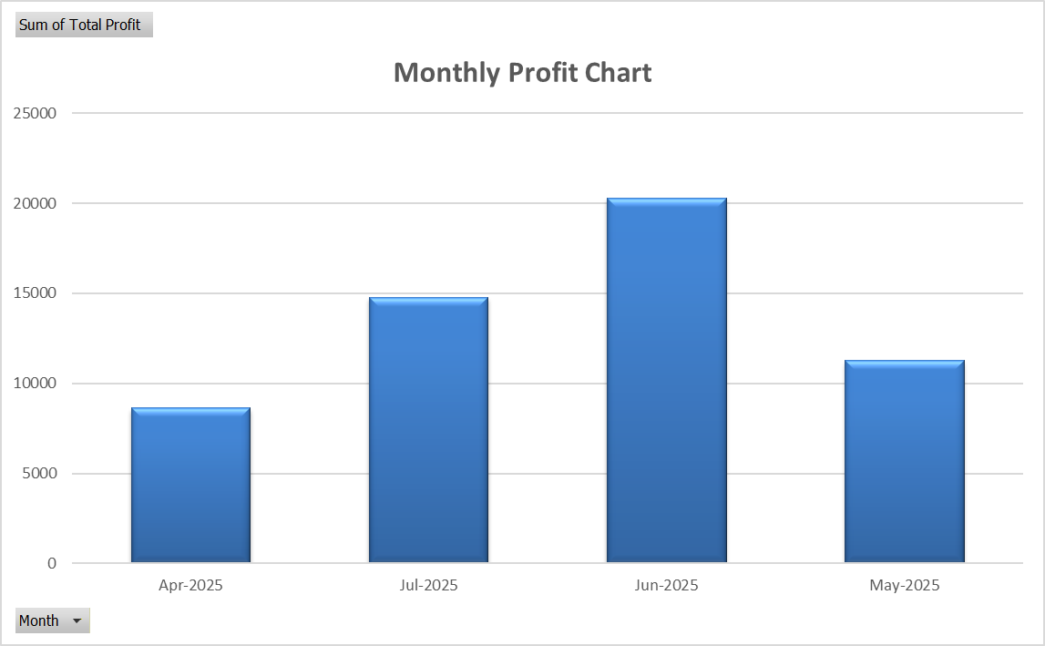
6.4 Retail Sales Findings (Prepared Product Sales)
Analysis of 12 retail sales entries shows:
Key Metrics
- Average Profit Margin: 20.46%
- Highest Profit Item: Sofa + Centre Table (₹4,885 profit)
- Lowest Profit Item: Chair Set (₹1,500 profit)
- Total 4-Month Retail Profit: ₹31,094
- Total Raw Material Profit: ₹54,979.5
- Combined Total Profit: ₹86,073.50
Interpretation
- Retail products have higher profit margins but lower frequency.
- Raw material sales dominate revenue due to consistent B2B demand.
- Retail sales depend on customer walk-ins and product displays; improving showroom layout could increase volume.

